THE UNITED REPUBLIC OF TANZANIA


PRESIDENTS’ OFFICE
REGIONAL ADMINISTRATION AND LOCAL GOVERNMENT
FORM SIX PRE – MOCK EXAMINATIONS, SEPT. 2018, RUVUMA REGION
133/2 BIOLOGY 2

TIME 3 HOURS
Instructions
- This paper consists of section A,B,C and D with a total of eight (08) questions
- Answer five(5) questions by choosing at least one (01) question from each section
- Each question carries twenty( 20) marks
- Except for diagram that must be drawn in pencil, all writing should be in blue or black ink
- Cellular phones and any unauthorized materials are not allowed in the examination room.
- Write your examination number on every page of your booklet(S)

SECTION A
- (a) By using suitable example, explain the economic importance of bacteria (Give five points)
(b) Give five (05) reasons to justify the class in which spider belongs
- (a) By using the relevant curve, describe the growth pattern in arthropods
(b) Describe the types, location, role and effects meristematic cells

SECTIOON B
- (a) A father with blood group A and a mother of blood group B (both heterozygous) have four children. What is the probability that the children will have blood group A?
(b) Elaborate Mendel’s work in genetic considering his success and failures (three points each)
- (a) The diagram below represents a small portion of the molecular structure of a nucleic acid

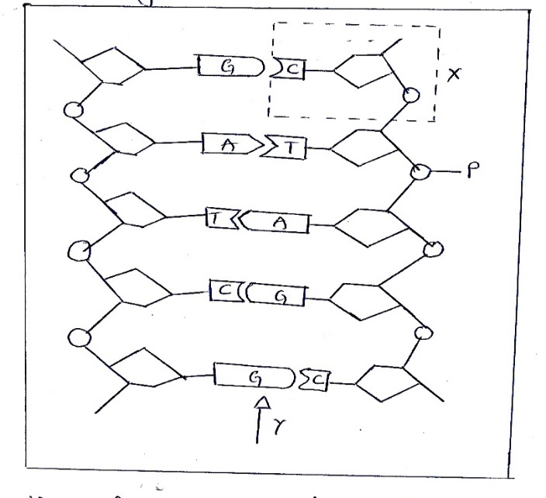
Name the part molecule indicated by the dotted box labeled X
- What do the letters A, C, D, G, P and T in the diagram represent?
- What type of chemical bond is found at the point indicated by an arrow labeled Y?
(b) Describe the properties which account for the DNA’s suitability as material for heredity.

SECTION C
- Explain the following types of growth, give one example in each case
- Intermittent growth
- Allometric growth
- Isometric growth
- limited growth
- Unlimited growth

- Explain different ways used by endotherms to keep their body temperature constant (give five points)

SECTION D
- Explain how a quadrant can be used to carry out an ecological study of a plant species
- Use four appropriate theories to explain the origin of life and for each theory point out the strength and weakness.

